**Practical No. 3**

**Write a PHP program to demonstrate the use of looping structures using-  
a. While statement, b. Do-while statement, c. For statement, d. Foreach statement.**

**Code (Pg no. 104):**

<?php

$i=0;

*while*($i<=10)

{

    echo "$i<br/>";

    $i+=2;

}

?>

**Output:**

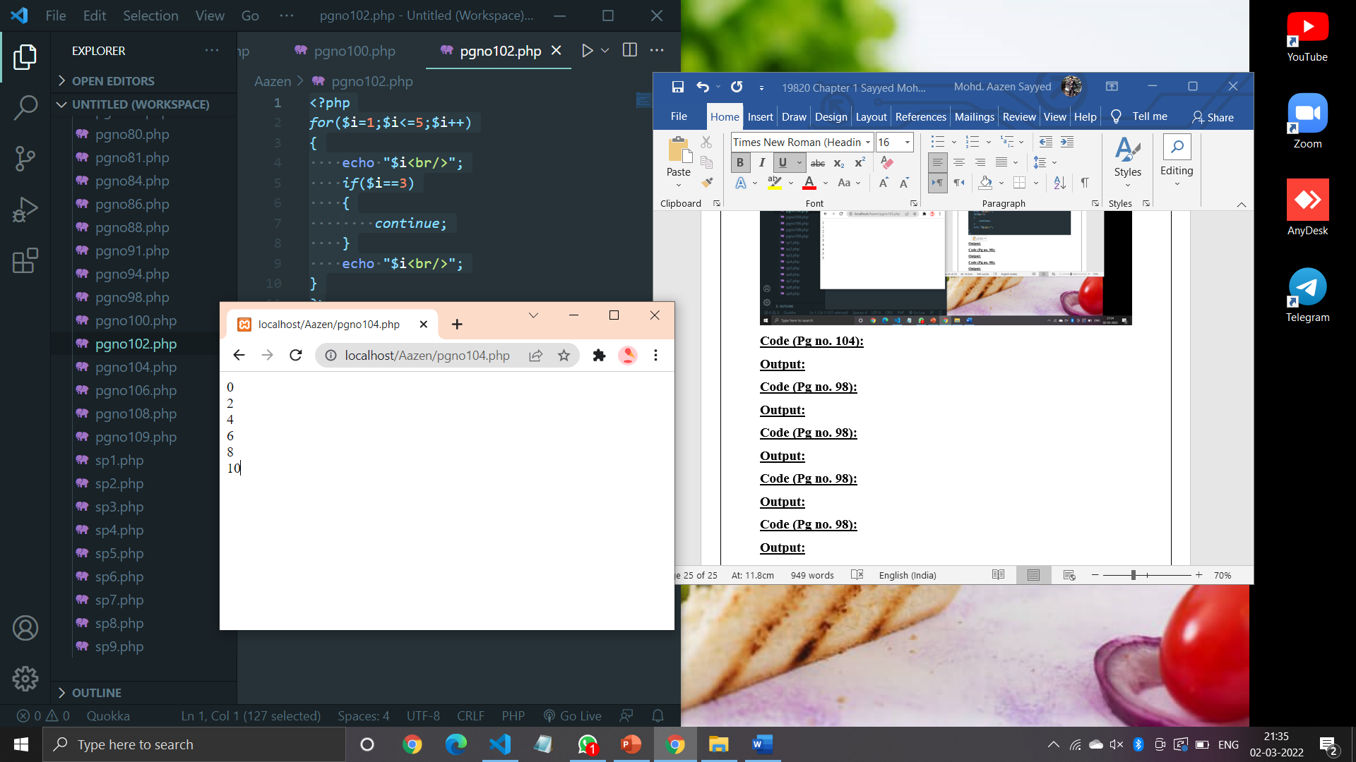

**Code (Pg no. 106):**

<?php

$i=1;

*do*{

    echo "$i<br/>";

    $i+=2;

}

*while*($i<10);

?>

**Output:**

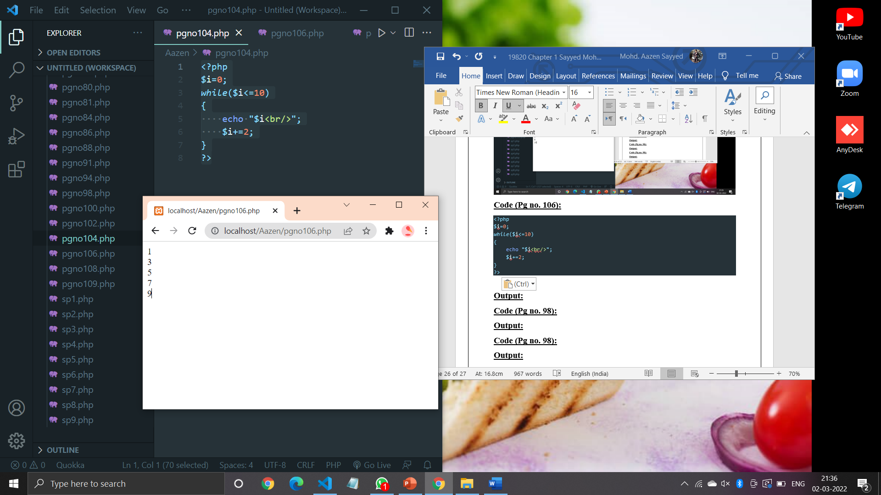

**Code (Pg no. 108):**

<?php

$num=0;

*for*($i=0;$i<=10;$i+=2)

{

    echo "$i<br/>";

    $num+=$i;

}

echo "Sum = $num";

?>

**Output:**

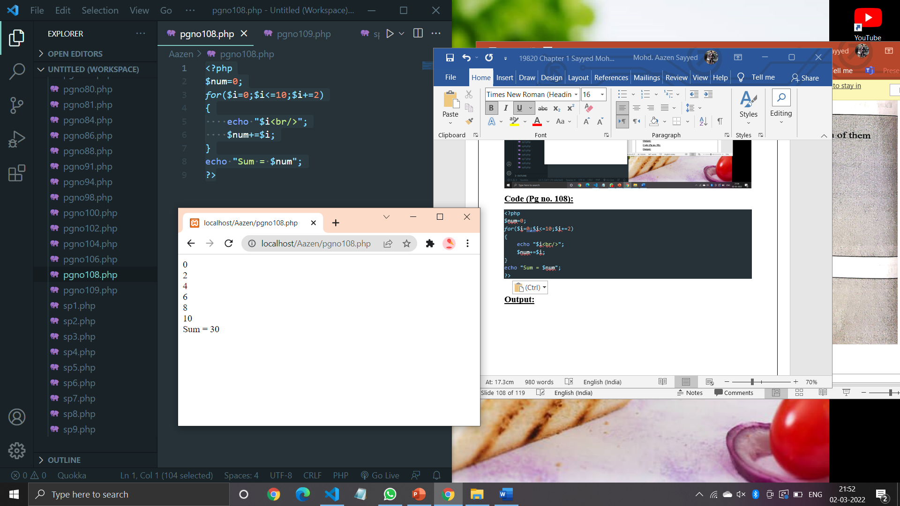

**Code (Pg no. 109):**

<?php

$arr=array(10,20,30,40,50);

*foreach*($arr as $i)

{

    echo "$i<br/>";

}

?>

**Output:**

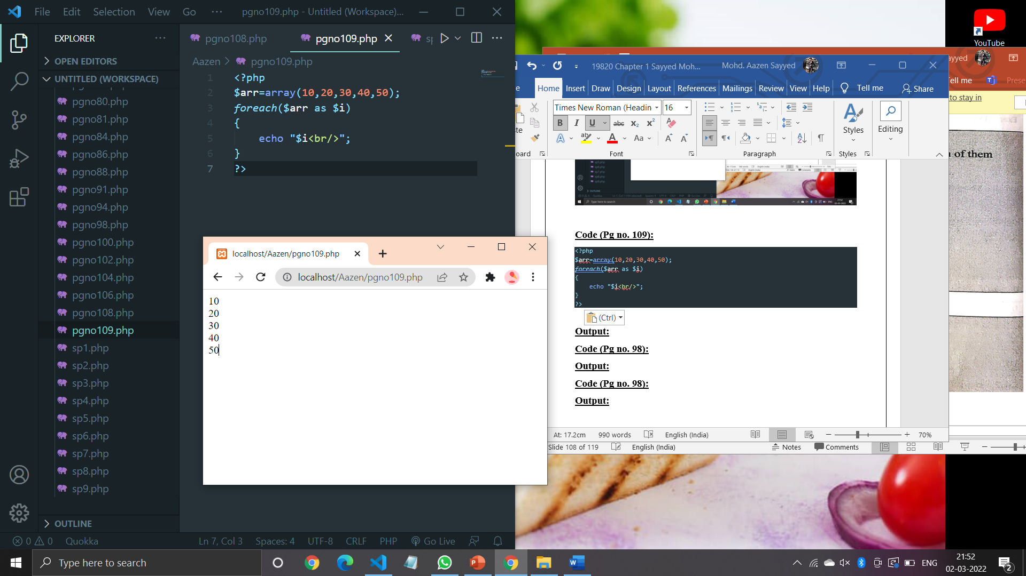

**Code (Pg no. 110):**

<?php

echo ("Welcome to PHP");

?>

**Output:**

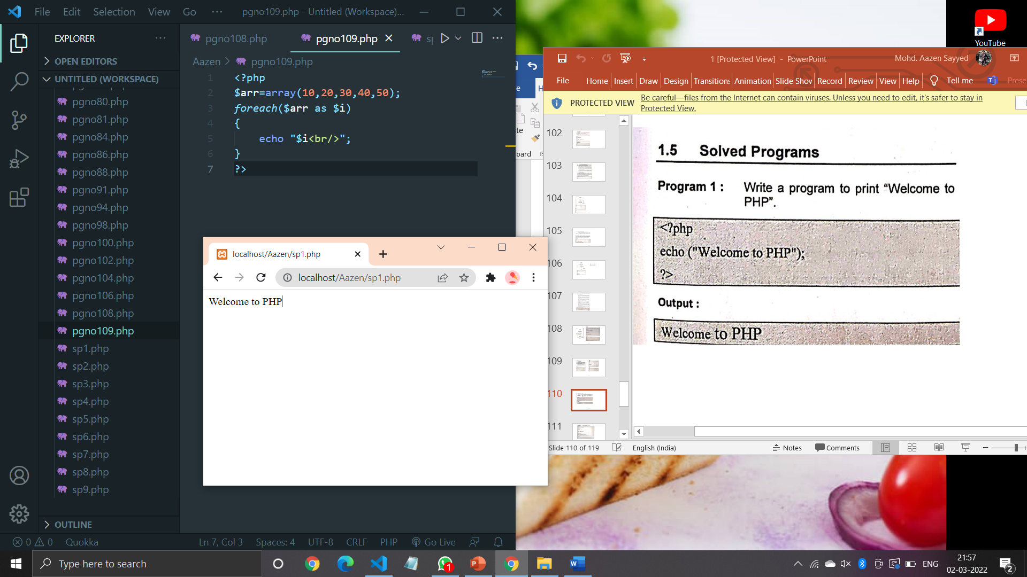

**Code (Pg no. 111):**

<?php

function my_sqrt($n)

{

    $x=$n;

    $y=1;

*while*($x>$y)

    {

        $x=($x+$y)/2;

        $y=$n/$x;

    }

*return* $x;

}

print_r(my_sqrt(16)."<br/>");

print_r(my_sqrt(144)."<br/>");

?>

**Output:**

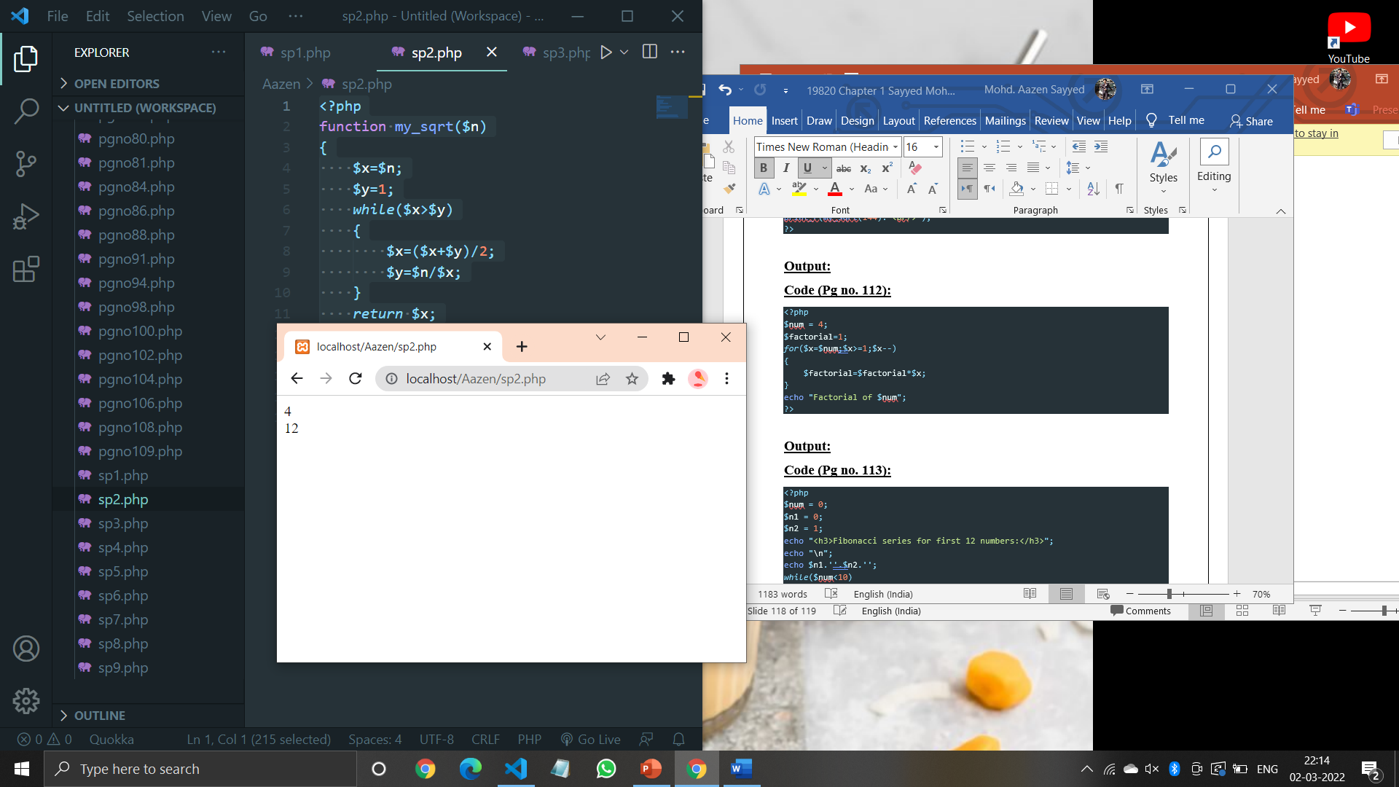

**Code (Pg no. 112):**

<?php

$num = 4;

$factorial=1;

*for*($x=$num;$x>=1;$x--)

{

    $factorial=$factorial*$x;

}

echo "Factorial of $num";

?>

**Output:**

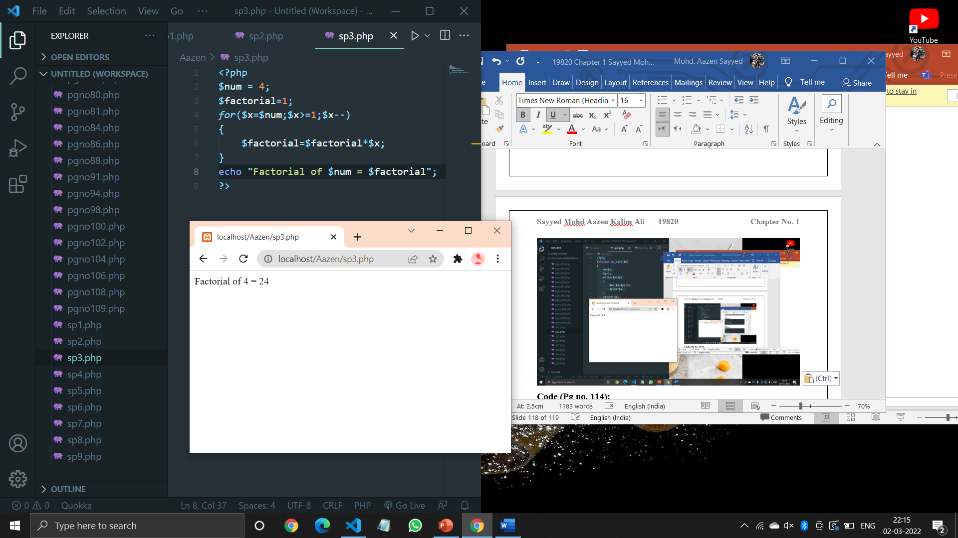

**Code (Pg no. 113):**

<?php

$num = 0;

$n1 = 0;

$n2 = 1;

echo "<h3>Fibonacci series for first 12 numbers:</h3>";

echo "\n";

echo $n1.''.$n2.'';

*while*($num<10)

{

    $n3=$n2+$n1;

    echo $n3.'';

    $n1=$n2;

    $n2=$n3;

    $num=$num+1;

}

?>

**Output:**

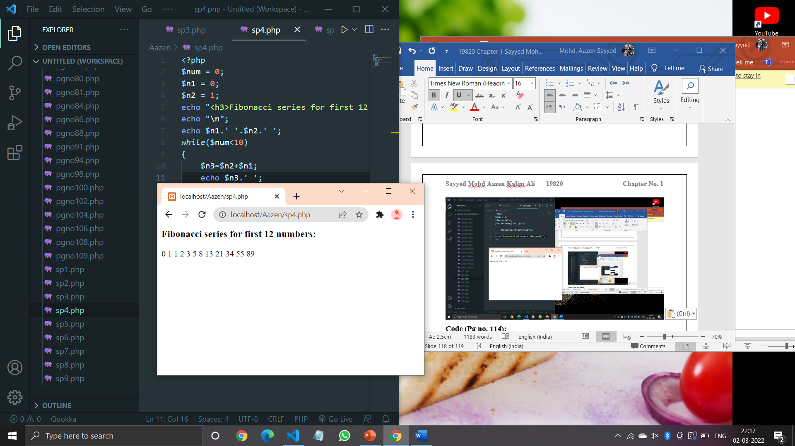

**Code (Pg no. 114):**

<?php

$count=0;

$number=2;

*while*($count<20)

{

    $div_count=0;

*for*($i=1;$i<=$number;$i++)

    {

*if*(($number%$i)==0)

        {

            $div_count++;

        }

    }

*if*($div_count<3)

    {

        echo $number." , ";

        $count=$count+1;

    }

    $number=$number+1;

}

?>

**Output:**

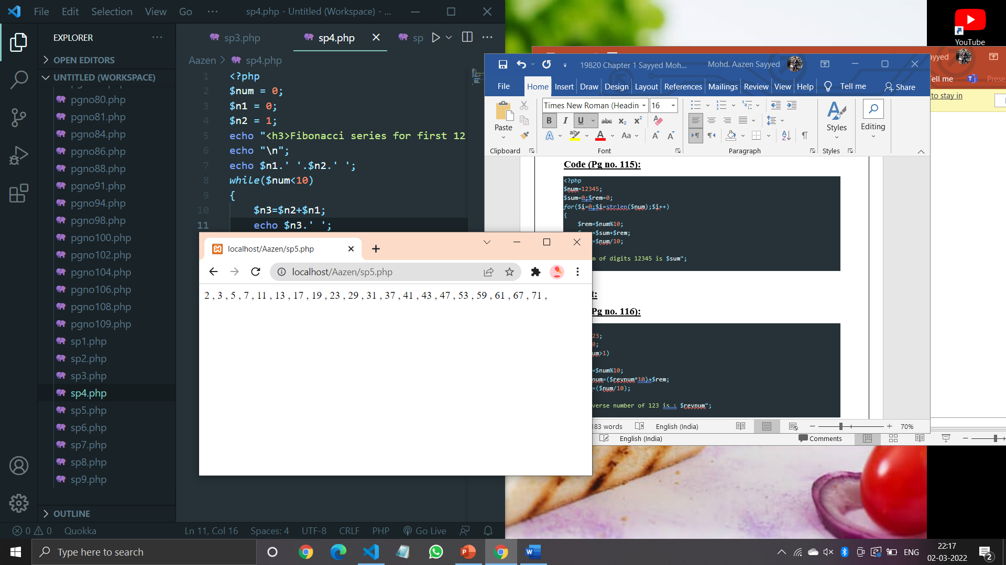

**Code (Pg no. 115):**

<?php

$num=12345;

$sum=0;$rem=0;

*for*($i=0;$i<=strlen($num);$i++)

{

    $rem=$num%10;

    $sum=$sum+$rem;

    $num=$num/10;

}

echo "Sum of digits 12345 is $sum";

?>

**Output:**

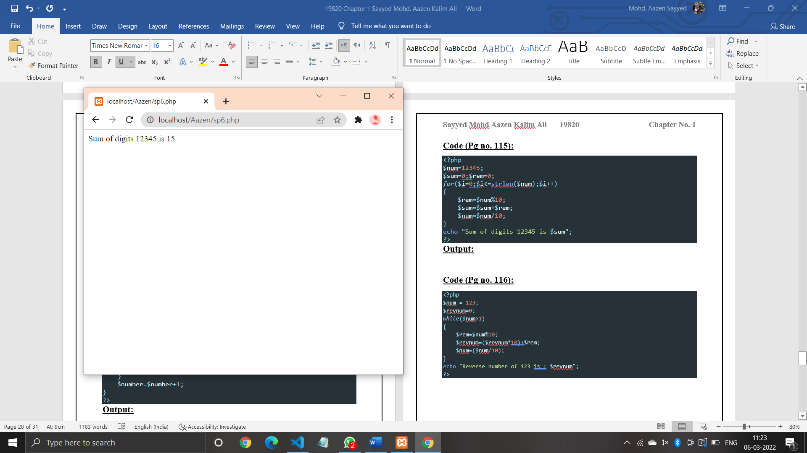

**Code (Pg no. 116):**

<?php

$num = 123;

$revnum=0;

*while*($num>1)

{

    $rem=$num%10;

    $revnum=($revnum*10)+$rem;

    $num=($num/10);

}

echo "Reverse number of 123 is : $revnum";

?>

**Output:**

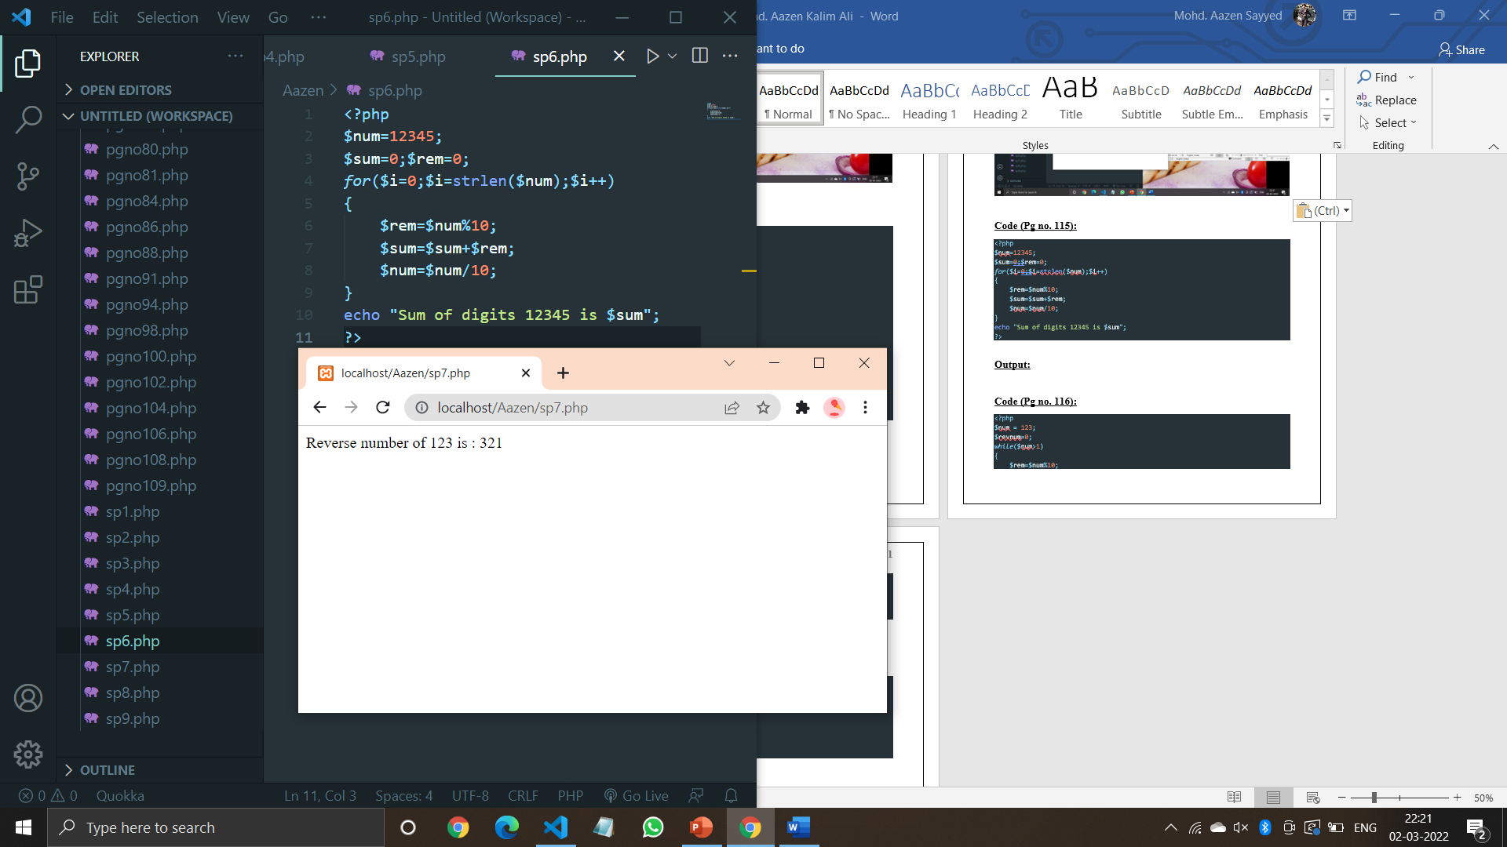

**Code (Pg no. 117):**

<?php

$sum=0;

*for*($i=0;$i<=10;$i+=2)

{

    echo "$i<br/>";

    $sum=$sum+$i;

}

echo "Sum: $sum";

?>

**Output:**

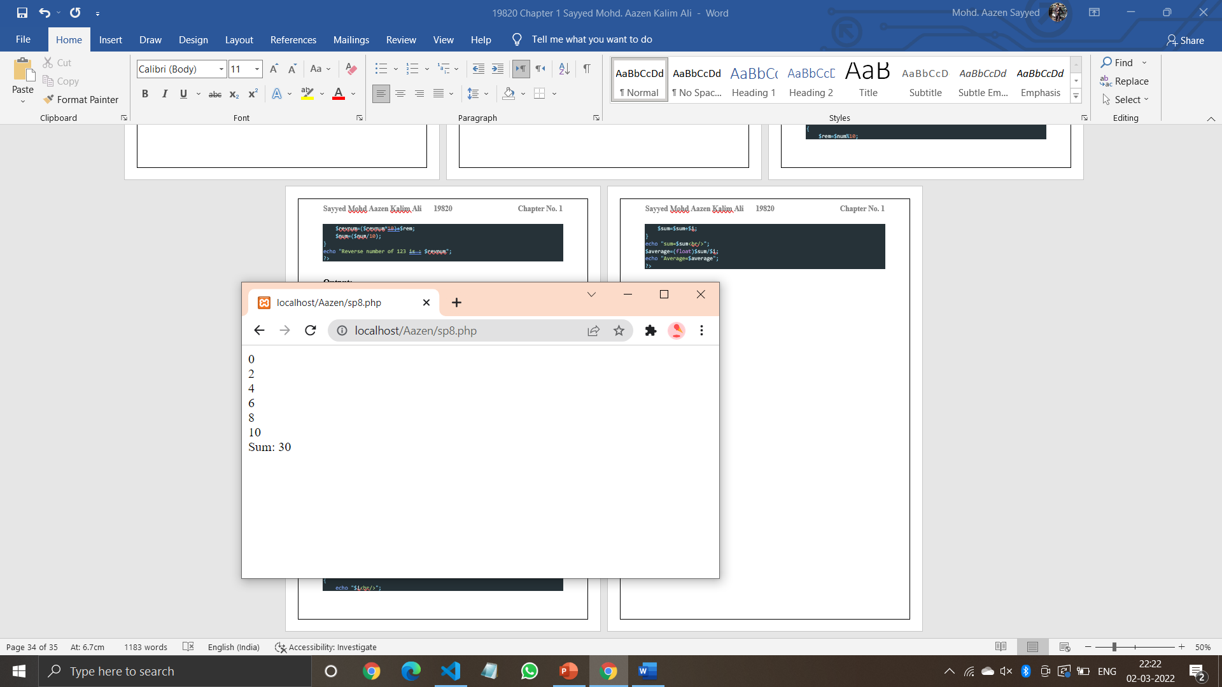

**Code (Pg no. 118):**

<?php

$sum = 0;

*for*($i=1;$i<=10;$i++)

{

    echo "$i<br/>";

    $sum=$sum+$i;

}

echo "sum=$sum<br/>";

$average=(float)$sum/$i;

echo "Average=$average";

?>

**Output:**

